Define the problem

Describe the solution

Implement the solution

* And operator
* Or operator
* Not operator

Logic gates implements a logic function

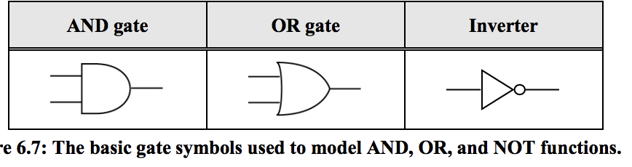

And and or gates can have as many inputs as needed